ECE 3441 Spring 2024

Exam 2

Version A Solutions

Please do not open the booklet unless instructed to do so, or a substantial penalty will result.

- Closed book, closed notes
- ONE 8.5 x 11” double-sided cheat sheet is allowed.
- Only four function calculators are allowed.
- Show all details of your work to obtain credit (The answer alone will not suffice).
- You may not talk during the quiz to others or to yourself.
- You have 80 minutes.

First Name Last Name, Peoplesoft ID, Date DD/MM/YYYY

Question | Points | Maximum
1 |  | 15
2 |  | 20
3 |  | 20
4 |  | 20
5 |  | 20
6 |  | 15

Total: _______/100 possible points + 10 Bonus

Question 1:
A M-K flip-flop behaves as follows:
If M = K’, the flip-flop changes state
If MK = 11, the flip-flop does not change state.
If MK = 00, the next state is set to 1.
PreN and ClrN are asynchronous active-low inputs.
- Construct the M-K flip-flop truth table.
- Give the characteristic (next-state) equation for the M-K flip-flop.
- Complete the timing diagram below for the rising-edge triggered M-K flip-flop. Assume there is no time delay and initially Q = 0.
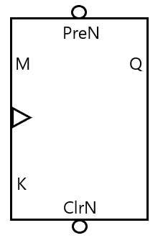
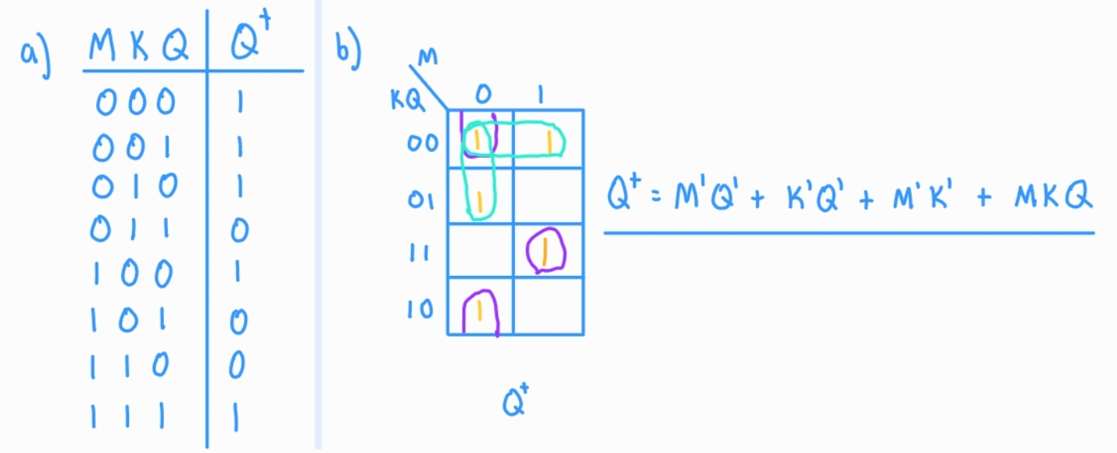
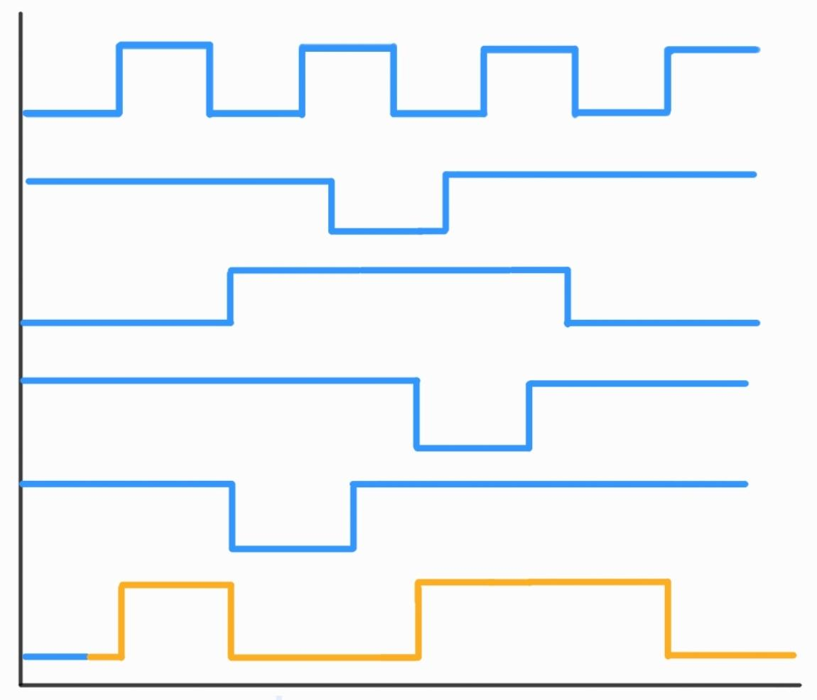
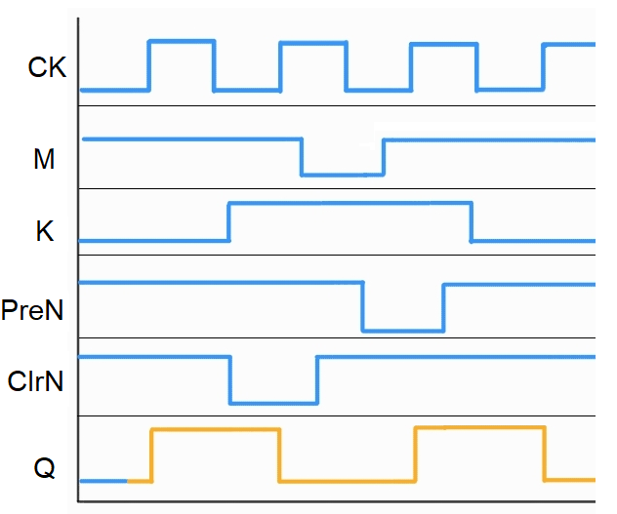

Question 2:
A sequential circuit has one input (X), one output (Z), and 3 D flip-flops. The transition table with the output is given as:
A B C | A⁺ B⁺ C⁺ |  | Output (Z)
 | X = 0 | X = 1 | X = 0 | X = 1
0 0 0 | 0 1 0 | 0 0 1 | 0 | 0
0 0 1 | 1 0 0 | 0 0 0 | 0 | 1
0 1 0 | 0 1 1 | 1 0 0 | 0 | 1
0 1 1 | 0 0 0 | 0 1 0 | 1 | 0
1 0 0 | 0 0 0 | 0 1 1 | 0 | 0

- What are the equations for each of the flip-flop D inputs and the equation for the output?
- Is this a Mealy or a Moore machine?
A | B | C | X | A+ | B+ | C+ | Z
0 | 0 | 0 | 0 | 0 | 1 | 0 | 0
0 | 0 | 0 | 1 | 0 | 0 | 1 | 0
0 | 0 | 1 | 0 | 1 | 0 | 0 | 0
0 | 0 | 1 | 1 | 0 | 0 | 0 | 1
0 | 1 | 0 | 0 | 0 | 1 | 1 | 0
0 | 1 | 0 | 1 | 1 | 0 | 0 | 1
0 | 1 | 1 | 0 | 0 | 0 | 0 | 1
0 | 1 | 1 | 1 | 0 | 1 | 0 | 0
1 | 0 | 0 | 0 | 0 | 0 | 0 | 0
1 | 0 | 0 | 1 | 0 | 1 | 1 | 0
1 | 0 | 1 | 0 | X | X | X | X
1 | 0 | 1 | 1 | X | X | X | X
1 | 1 | 0 | 0 | X | X | X | X
1 | 1 | 0 | 1 | X | X | X | X
1 | 1 | 1 | 0 | X | X | X | X
1 | 1 | 1 | 1 | X | X | X | X
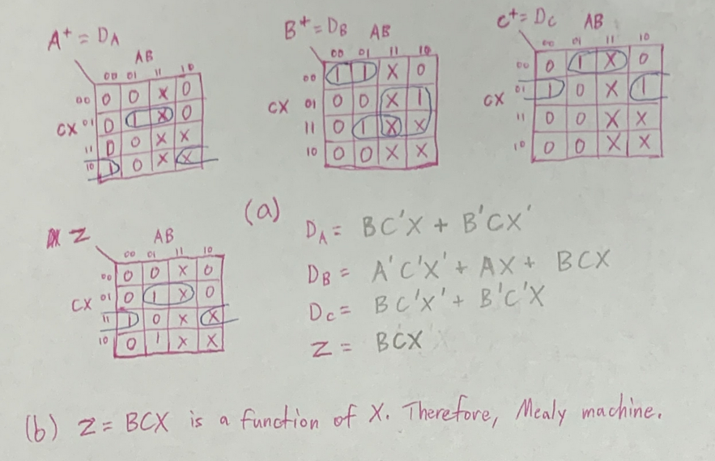

Question 3:
A Moore state machine has two inputs X1 and X2. Z = 1 only if the last 2 inputs of X1 and X2 were the inverse of each other. The following is an example sequence:

X1: 0 0 0 0 0 1 1 0 0 1 1 1 1 1
X2: 0 1 1 1 0 1 0 0 1 0 0 1 0 1
Z: 0 0 1 1 0 0 0 0 0 1 1 0 0 0

Draw the state graph for this circuit (hint: each possible input combination should have a transition arrow. e.g. XY = 00/01/10/11).
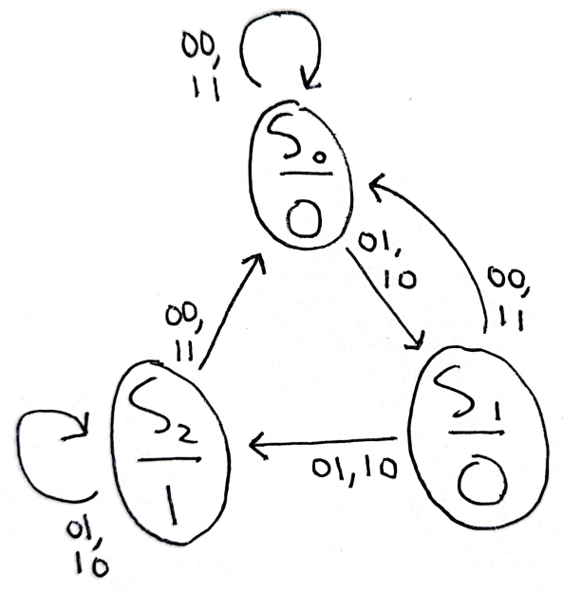

Question 4:
Create minimum Mealy state graphs with the properties described in (a) and (b). Both have one input (X) and one output (Z). An example input sequence X and output sequence Z is provided for each.
- Create a minimum Mealy state graph that detects the sequence 101 in X. It should output Z=1 every time the sequence is detected and Z=0 otherwise. (Hint: best is 3 states)
X = 0 1 0 1 1 0 0 1 0 1 0 1 0 1 1 0 1
Z = 0 0 0 1 0 0 0 0 0 1 0 1 0 1 0 0 1
- Create a minimum Mealy state graph that detects the sequences 101 and 110 in X. It should output Z=1 every time either sequence is detected and Z=0 otherwise. (Hint: best is 4 states)
X = 1 0 1 1 0 1 1 0 0 1 1 1 1 0 1 0 1
Z = 0 0 1 0 1 1 0 1 0 0 0 0 0 1 1 0 1

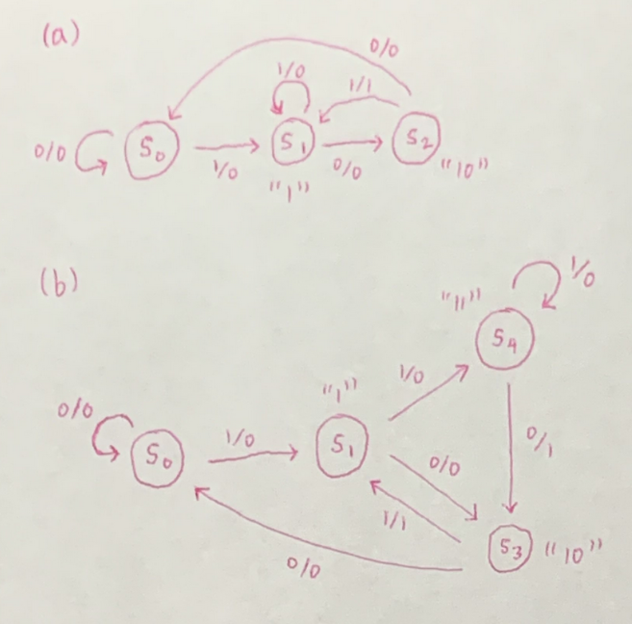

Question 5:
Given the following B-C latch:
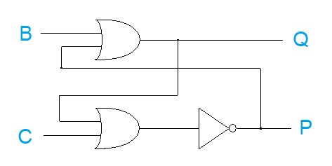
- Determine the restrictions that must be placed on B and C so that Q = P’ and the latch is stable under steady-state conditions.

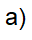
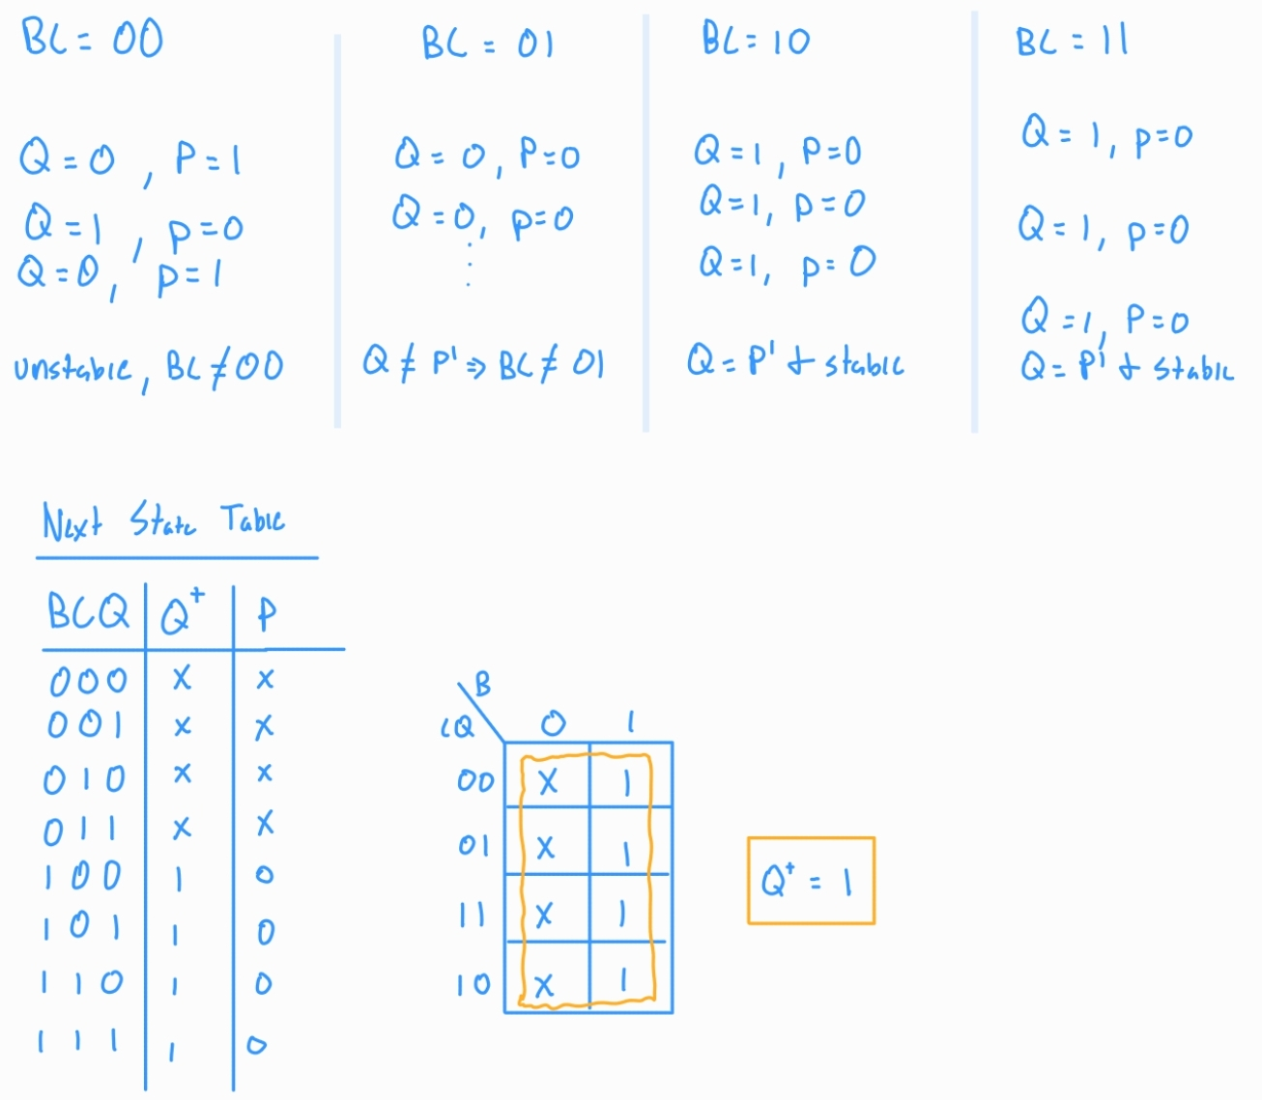
- Construct the next-state truth table for both outputs of the B-C latch and derive the next-state equation for Q+

Question 6:
Based on the following 3-bit Johnson counter, what sequence of states does the counter go through if it is started in state 110?

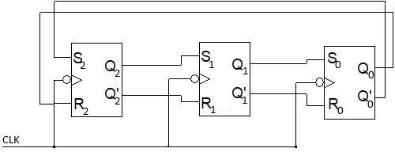
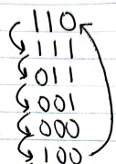

Extra Paper

